Dataset used in this project.



Analyzing and comparing data for unemployment.

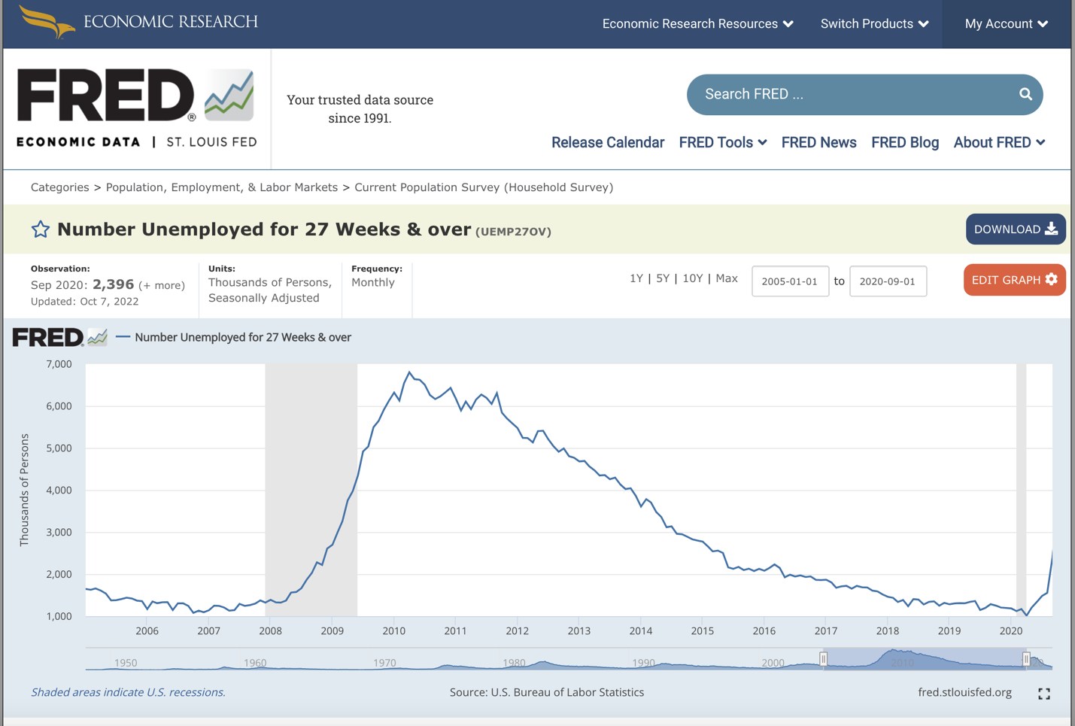

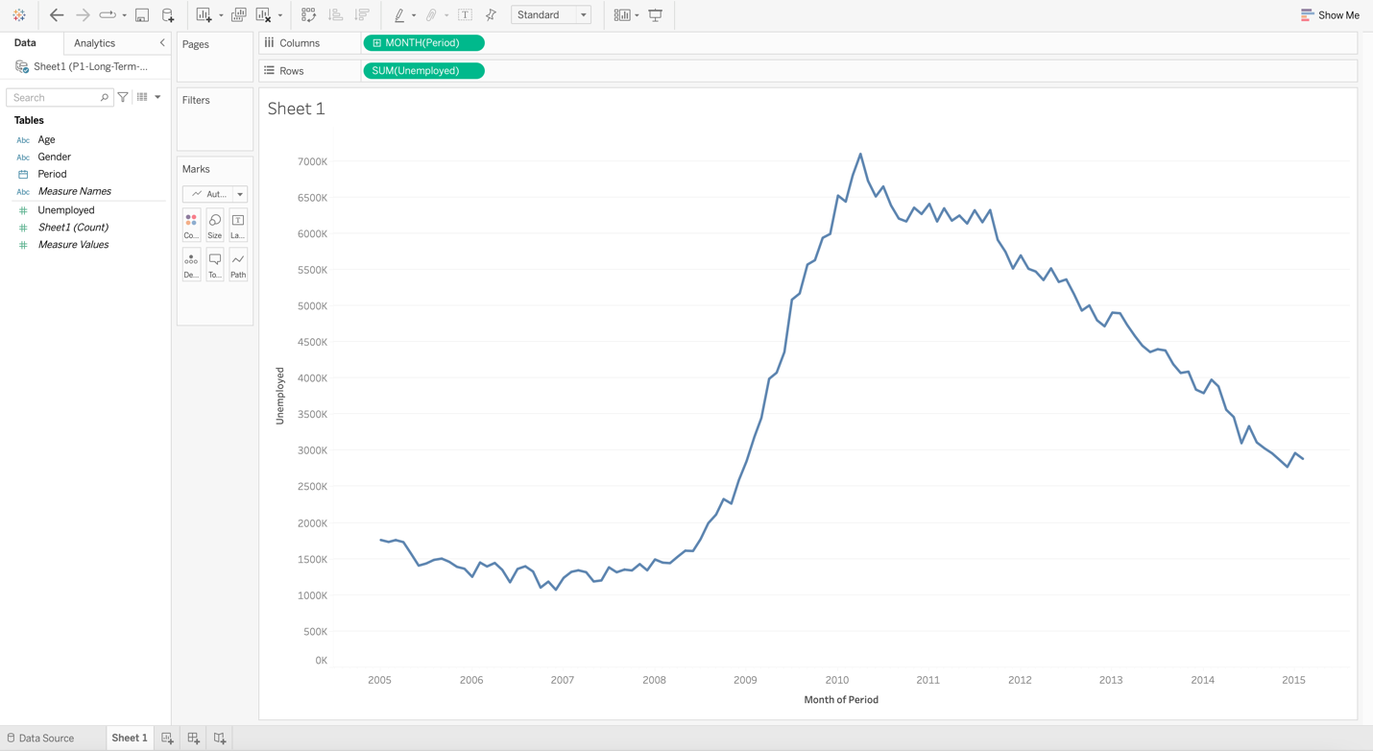

Increasing Granularity

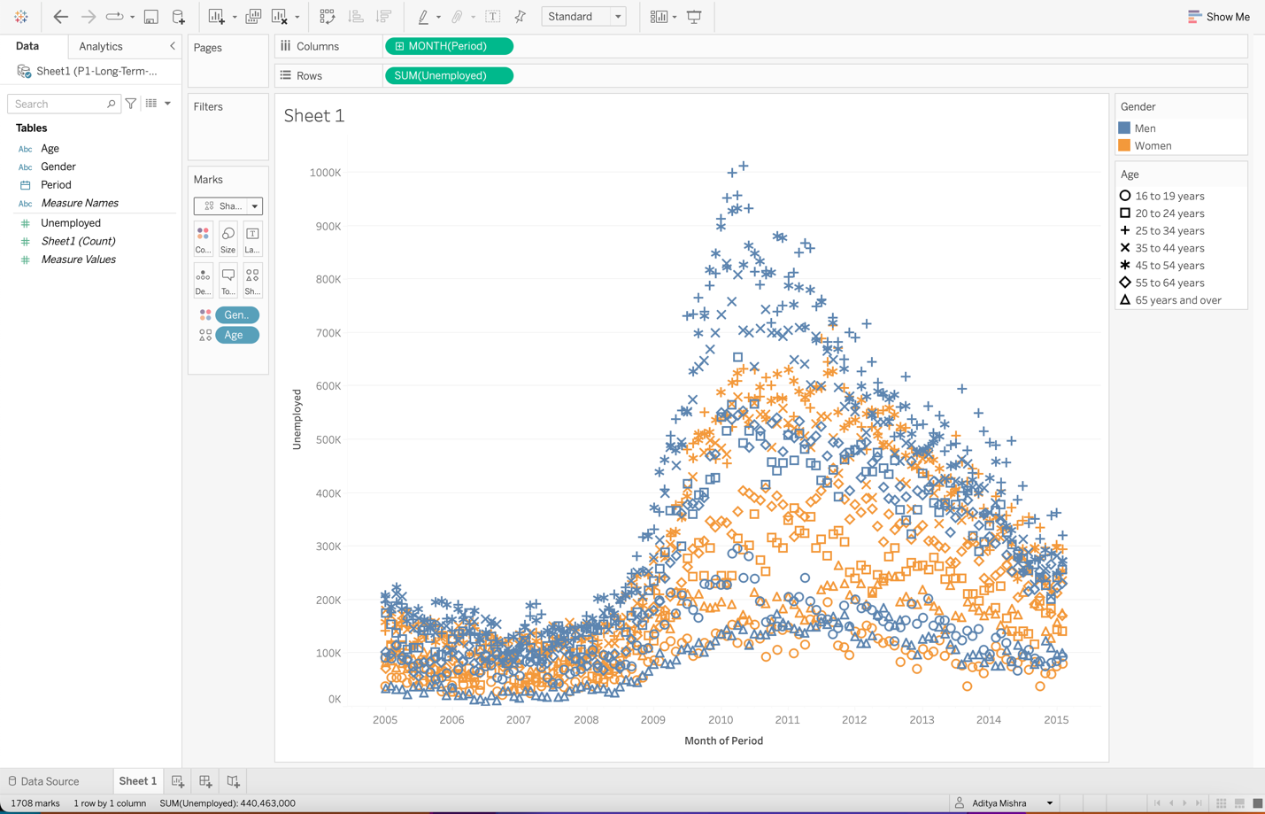

Representing Data Using Average

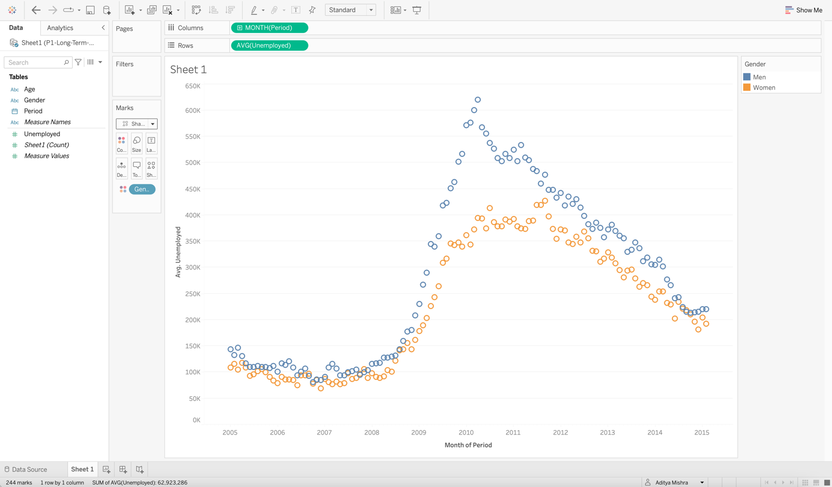

Increasing data granularity through average.

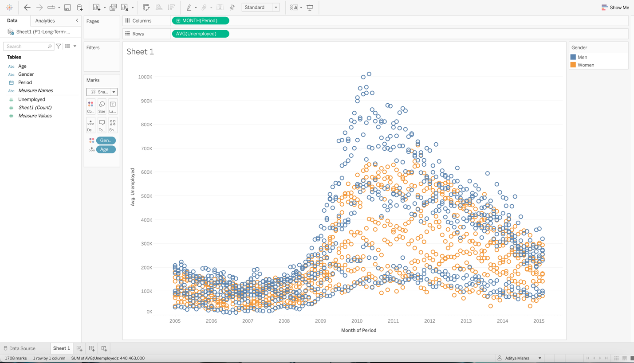

Showing data about unemployment of different gender and age, based on sex = “Women”

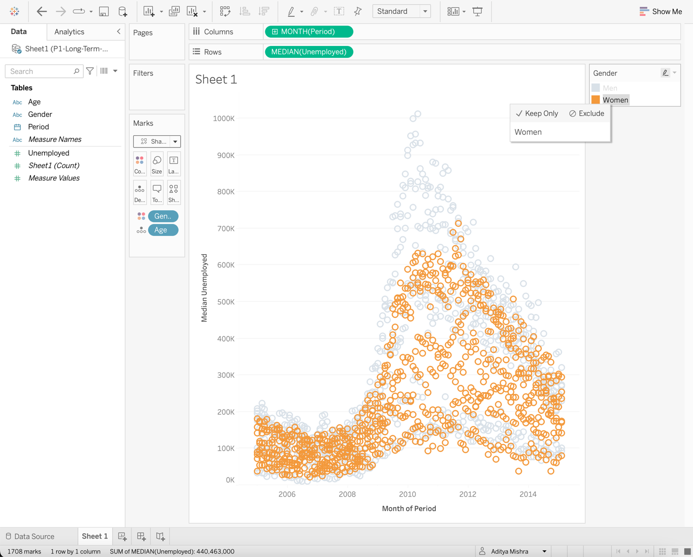

Showing data about unemployment of different gender and age, based on sex = “Men”

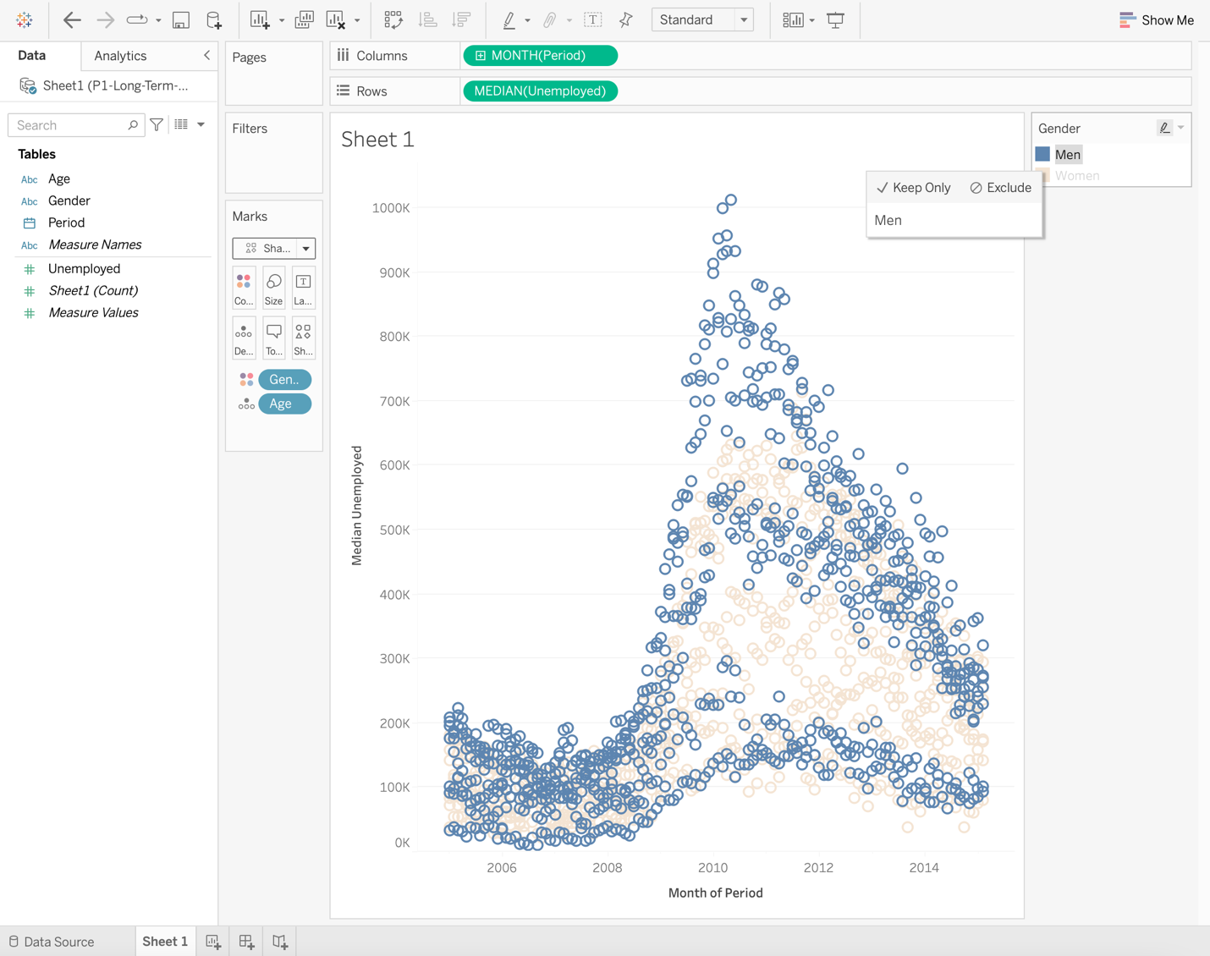

Showing data about unemployment of different gender and age, based on Age Group = “35-44”

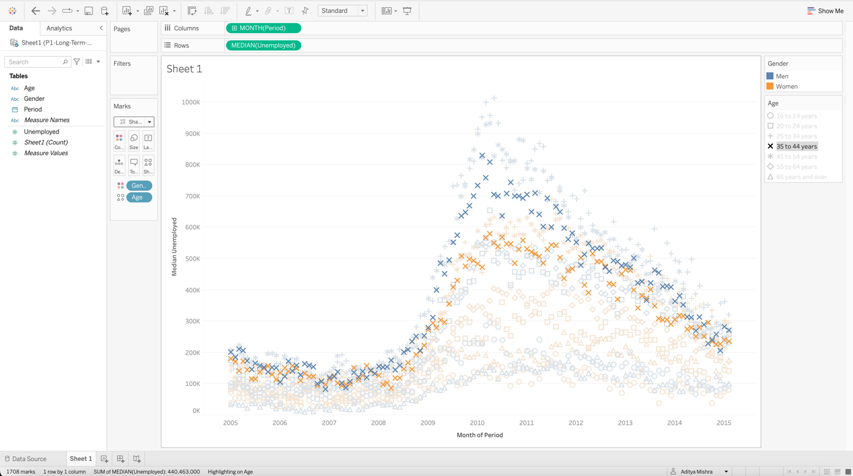

Area chart of unemployment based on age.

Using filter to represent data of only men unemployment in an area chart

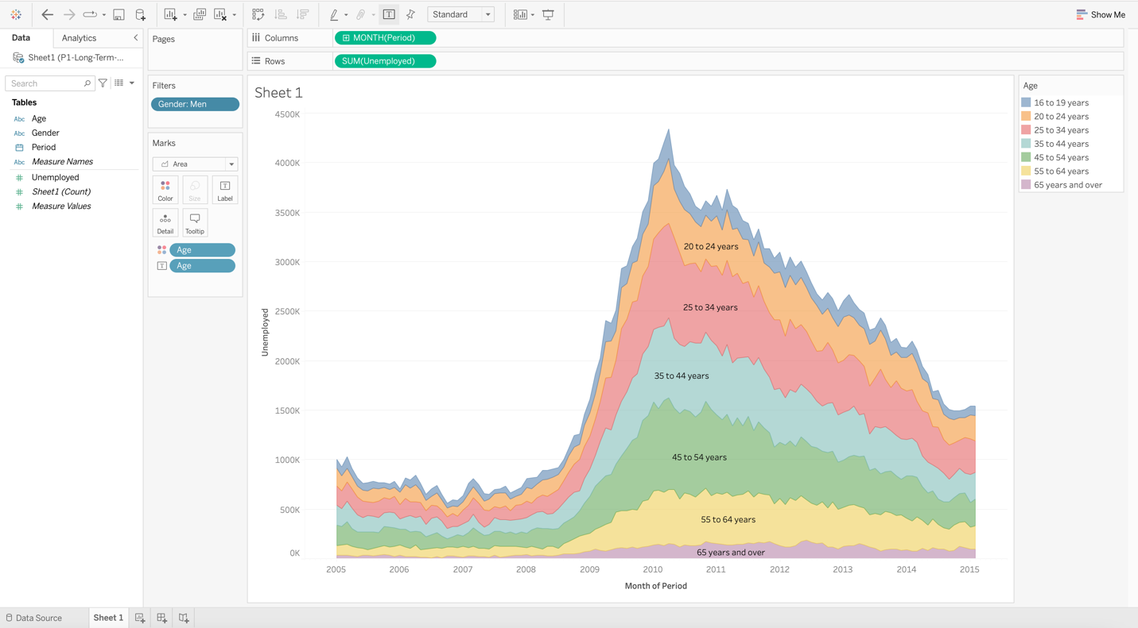

Using filter to represent data of only women unemployment in an area chart

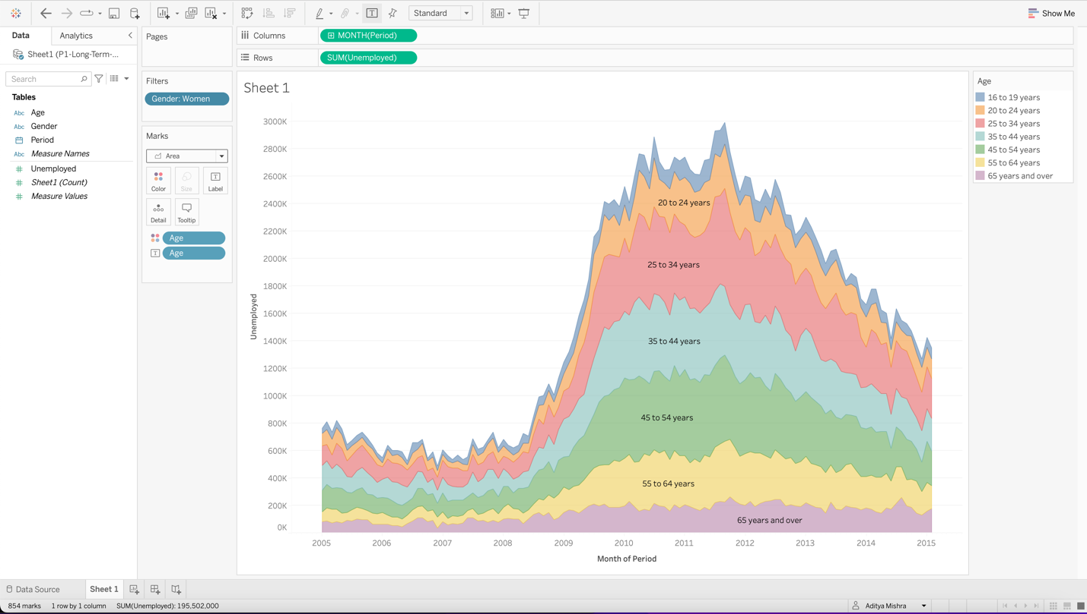

Using filter to represent data of only men unemployment in an area chart through quick filter.

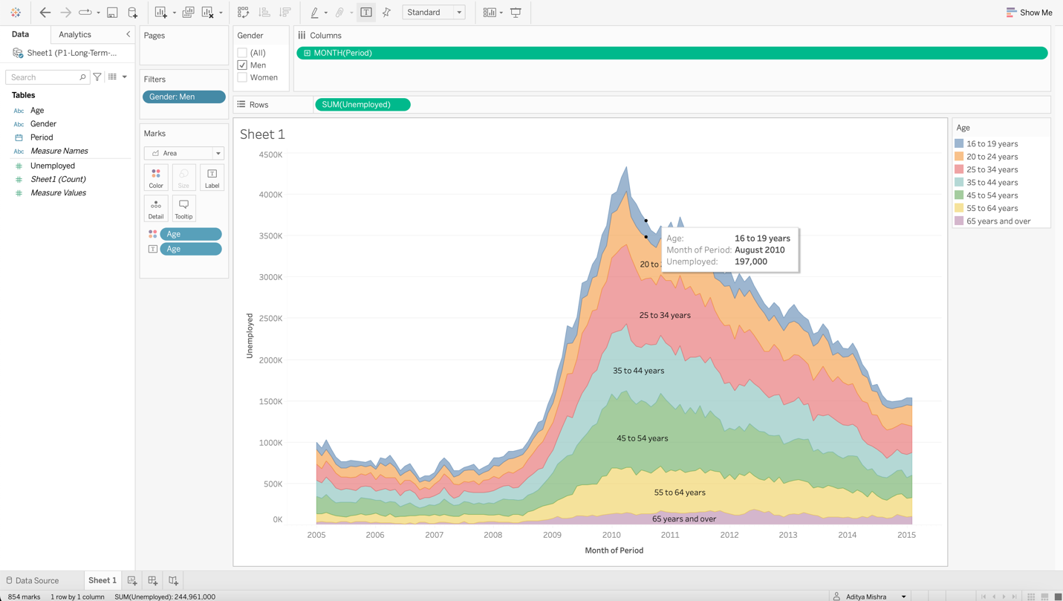

Using filter to represent data of only women unemployment in an area chart through quick filter.

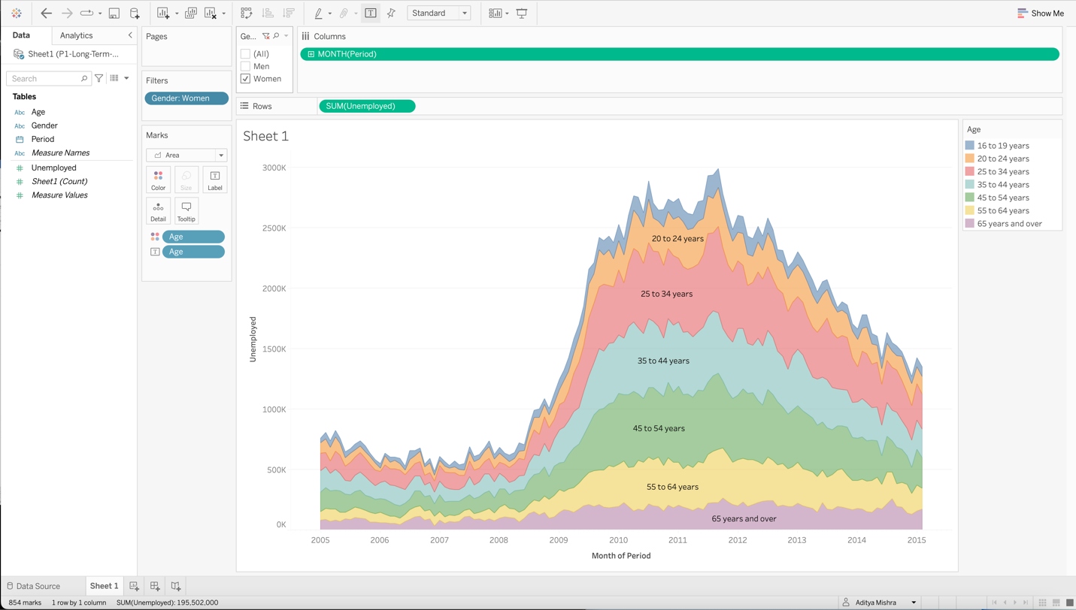

Using double quick filter to represent data of only women between age of 20-24 unemployment in an area chart.

